myEHR

Style-Guide and Design Documentation

Mid-State IT SOFTWARE DEVELOPER Capstone

2024

Table of Contents

Introduction 3

Logo 3

Color Palette 4

Forms 4

Navbars/Banners 5

Conclusion 6

# Introduction

In this document, we will address the style and design of the myEHR web application. The document is a guide that will contribute to the efficiency and consistency of the application.

Technology used for the style and design of the web application include:

* CSS
* Bootstrap
* JavaScript

## Logo

myEHR’s logo was designed specifically for the project, implementing the Mid-State maroon color, and encapsulating the essence of the project in a simple yet strong way. Using this logo across all site views ensures brand consistency throughout the application.

There are various image files in the project’s wwwroot/Media folder that hold the logo and its styles. The file Media/myehr2-red.png is the main logo in the maroon color mentioned above. The same image can be found in white and black to allow for visual contrast where needed. There is also an alternative to the final logo in the same colors.

myEHR Logo Colors:

* #82142E
* #000000
* #FFFFFF

## Color Palette

These are the specific colors chosen to be used throughout the web application. The picture below illustrates the colors used for specific instances. These color definitions and any additional color choices can be found in the projects wwwroot/css/site.css file.

## Forms

Consistent styling, validation, and labels contribute to the incorporation of forms that are user-friendly, intuitive, and accessible. Input validation was applied on the client side using JavaScript and on the server side using Entity Framework as well as hard checks in the controller functions. This ensures not only that the database does not receive any inappropriate data, but also that the user receives valuable feedback regarding any rejected input so that they may make necessary changes to comply with form requirements in real time. Clear labels provide users with the information they need to fill out the forms appropriately.

Each form input field is accompanied by a label and an error message span. For example:



## Navbars/Banners

Maintaining consistency throughout the application’s navigation is a crucial element of the user experience. This section will show the current processes for all of the application’s navigation styles and the patient information banner.

Below is a picture of the site _Layout.cshtml navbar which is shown across the top of all pages. Note that the navbar options change based on a few variables:

* Whether the user is admin and logged in (admin is logged in in this example)
* Whether the search bar is in use (currently showing the icon that reveals the search bar)
* Whether dark mode is on or off (controlled by the toggle to the left of the search icon)



Below is a picture of the landing page navbar which is shown only on the landing page. This navbar has a single point of entry to the site to be used by admin users. This file can be found in Views/Shared/_landingNav.cshtml.

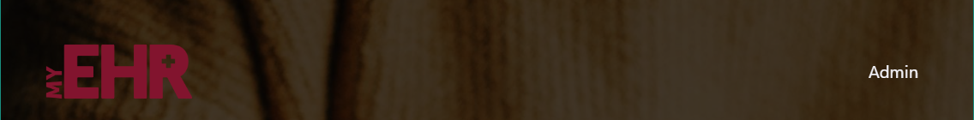

Below is a picture of the side-navbar which is shown on all patient detail pages. The code for this can also be found in _Layout.cshtml. In the example below, a patient has been selected, and the user is viewing their allergies. Other tabs may also be navigated through for additional patient detail views.

Below is a picture of what a patient information banner may look like. The purpose of this banner is for patient identification, using the common identifiers that can be seen at a glance. Additionally, this banner follows the user through each view associated with that patient to ensure that the records they are viewing or altering are affecting the intended patient.

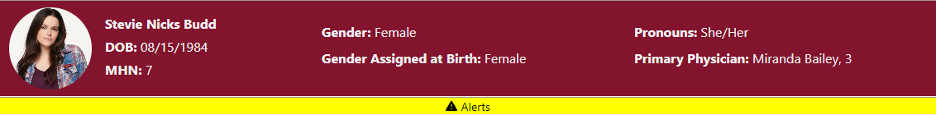

Note the ‘Alerts’ bar beneath the banner. That bar is only visible for patients that have alerts to be seen. Because this is not always present, there are two patient banner files to be maintained. Please take care to ensure that, outside of the addition of the alerts bar, that these are maintained in tandem to ensure consistency. Both files can be found in the Views/Shared folder.

# Conclusion

Style and design guides are essential for projects as they establish consistent standards, ensuring a unified and coherent visual and functional experience. By providing guidelines for elements such as colors, fonts, and layouts, these guides promote efficiency, scalability, and collaboration among team members. They play a pivotal role in maintaining brand identity, fostering a positive user experience, and facilitating adaptability to changing trends and requirements. Adhering to design guides reflects professionalism and helps create a polished, accessible, and maintainable project that can evolve while remaining cohesive. In essence, these guides serve as a crucial framework for achieving design consistency, usability, and long-term project success.